Key-Value Databases: Redis

# Installation

Install Redis and start its server.

$ sudo yum install -y redis

$ redis-server &

Press Enter after seeing *The server is now ready to accept connections*

# Strings in Redis

Launch Redis CLI.

$ redis-cli

Set the key hello to the value world

redis> set hello world

Get the value stored at the key hello

redis> get hello

Delete the key-value pair

redis> del hello

Try to get the value stored as the key hello.

redis> get hello

Copy and paste an output of the last command or a screenshot here and then continue with the Lab.

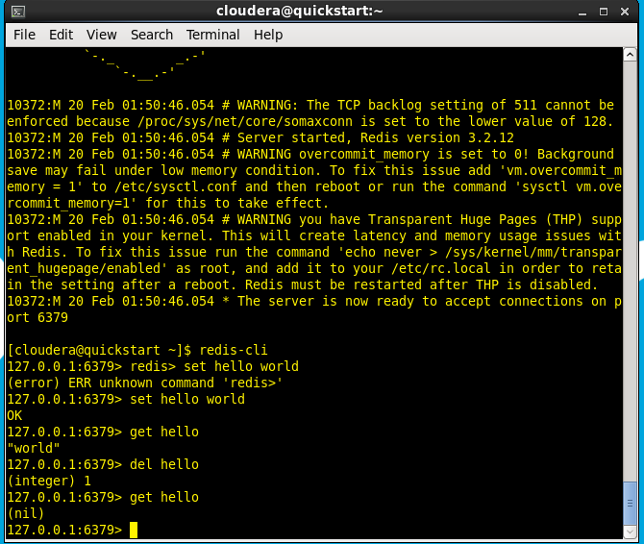

# Lists in Redis

Push items onto a list

redis> rpush list-key item

redis> rpush list-key item2

redis> rpush list-key item

Fetch the entire list by passing a range of 0 for the start index and -1 for the last index

redis> lrange list-key 0 -1

Fetch individual items from the list

redis> lindex list-key 1

Popping an item from the list makes it no longer available

redis> lpop list-key

redis> lrange list-key 0 -1

Copy and paste an output of the last command or a screenshot here and then continue with the Lab.

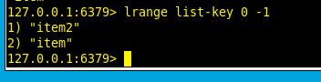

# Sets in Redis

Add items to a set, watch the output of the commands.

redis> sadd set-key item

redis> sadd set-key item2

redis> sadd set-key item3

redis> sadd set-key item

Fetch all of the items in the set

redis> smembers set-key

Ask Redis whether an item is in the list

redis> sismember set-key item4

redis> sismember set-key item

When removing items, our commands return the number of items that were removed

redis> srem set-key item2

redis> srem set-key item2

redis> smembers set-key

Copy and paste an output of the last command or a screenshot here and then continue with the Lab.

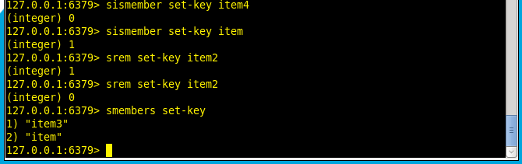

# Hashes in Redis

Add items to a hash, watch the output of the commands.

redis> hset hash-key sub-key1 value1

redis> hset hash-key sub-key2 value2

redis> hset hash-key sub-key1 value1

Fetch all of the items in the hash

redis> hgetall hash-key

When we delete items from the hash, the command returns whether the item was there before our try.

redis> hdel hash-key sub-key2

redis> hdel hash-key sub-key2

redis> hget hash-key sub-key1

Fetch individual fields from hashes

redis> hgetall hash-key

Copy and paste an output of the last command or a screenshot here and then continue with the Lab.

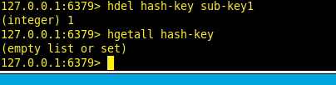

# Sorted Sets in Redis

Add items to a sorted set.

redis> zadd zset-key 728 member1

redis> zadd zset-key 982 member0

redis> zadd zset-key 982 member0

Fetch all of the items in a ZSet

redis> zrange zset-key 0 -1 withscores

Fetch a subsequence of items based on their scores

redis> zrangebyscore zset-key 0 800 withscores

Remove items, the command returns the number of items that were removed

redis> zrem zset-key member1

redis> zrem zset-key member1

redis> zrange zset-key 0 -1 withscores

Copy and paste an output of the last command or a screenshot here.

